**Write a program to print following patterns :**

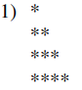

**CODE 1 :**

#include <stdio.h>

int main()

{

int n;

printf("Enter the number of rows: ");

scanf("%d", &n);

for (int i = 1; i <= n; i++)

{

for (int j = 1; j <= i; j++)

{

printf("* ");

}

printf("\n");

}

return 0;

}

**OUTPUT 1 :**

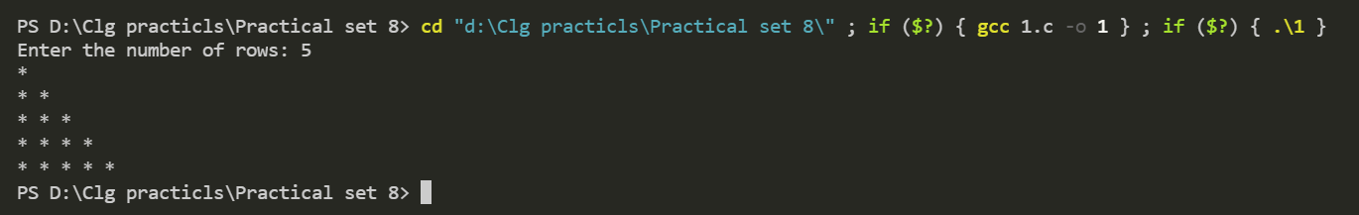

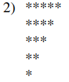

**CODE** 2 **:**

#include <stdio.h>

int main()

{

int n;

printf("Enter the number of row: ");

scanf("%d", &n);

for (int i = n; i >= 1; i--)

{

for (int j = i; j >= 1; j--)

{

printf("* ");

}

printf("\n");

}

return 0;

}

**OUTPUT 2 :**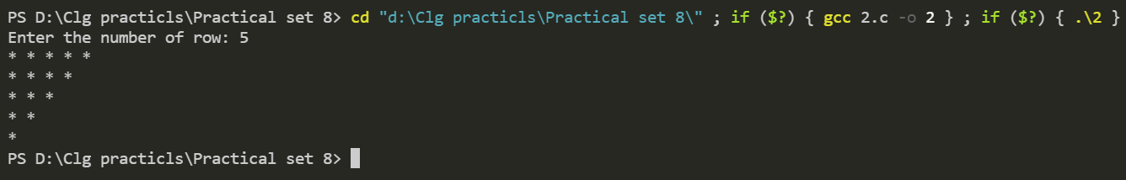

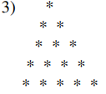

**CODE** 3 **:**

#include <stdio.h>

int main()

{

int n;

printf("Enter the number of row :");

scanf("%d", &n);

for (int i = 1; i <= n; i++)

{

for (int j = i; j < n; j++)

{

printf(" ");

}

for (int k = 1; k <= i; k++)

{

printf("* ");

}

printf("\n");

}

return 0;

}

**OUTPUT 3 :**

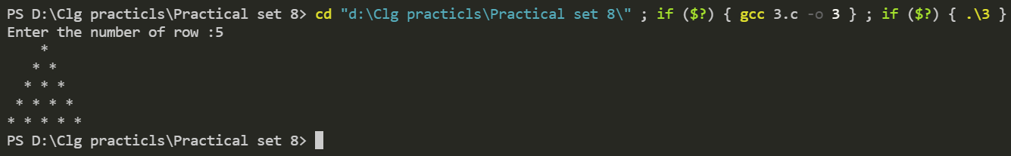

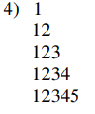

**CODE** 4 **:**

#include <stdio.h>

int main()

{

int n;

printf("Enter the number of rows: ");

scanf("%d", &n);

for (int i = 1; i <= n; i++)

{

for (int j = 1; j <= i; j++)

{

printf("%d", j);

}

printf("\n");

}

return 0;

}

**OUTPUT 4 :**

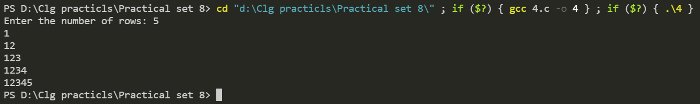

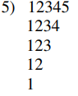

**CODE** 5 **:**

#include <stdio.h>

int main()

{

int n;

printf("Enter the number of row:");

scanf("%d", &n);

for (int i = n; i >= 1; i--)

{

for (int j = 1; j <= i; j++)

{

printf("%d", j);

}

printf("\n");

}

return 0;

}

**OUTPUT 5 :**

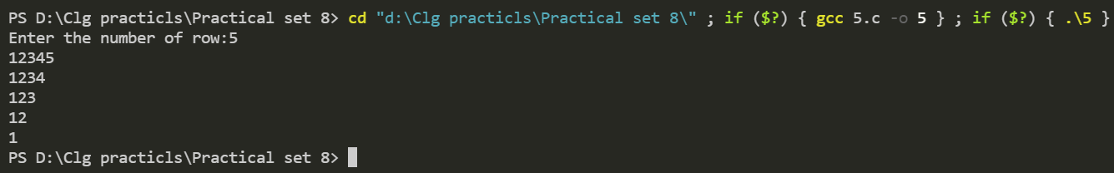

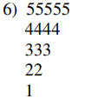

**CODE** 6 **:**

#include <stdio.h>

int main()

{

int n;

printf("Enter the number of row:");

scanf("%d", &n);

for (int i = n; i >= 1; i--)

{

for (int j = i; j >= 1; j--)

{

printf("%d", i);

}

printf("\n");

}

return 0;

}

**OUTPUT 6 :**

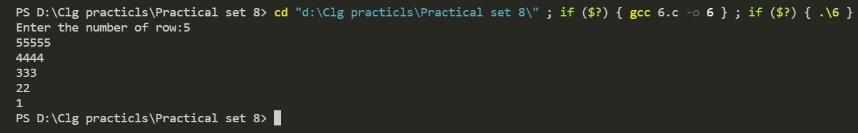

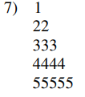

**CODE** 7 **:**

#include <stdio.h>

int main()

{

int n;

printf("\nEnter the number of rows: ");

scanf("%d", &n);

for (int i = 1; i <= n; i++)

{

for (int j = 1; j <= i; j++)

{

printf("%d ", i);

}

printf("\n");

}

return 0;

}

**OUTPUT 7 :**

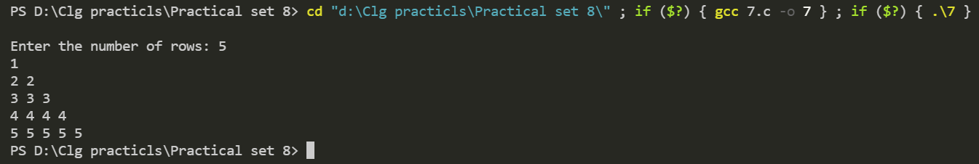

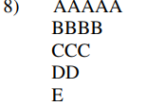

**CODE** 8 :

#include <stdio.h>

int main()

{

int n;

printf("Enter the number of rows: ");

scanf("%d", &n);

char c = 'A';

for (int i = n; i >= 1; i--)

{

for (int j = i; j >= 1; j--)

{

printf("%c ", c);

}

c++;

printf("\n");

}

return 0;

}

**OUTPUT 8 :**

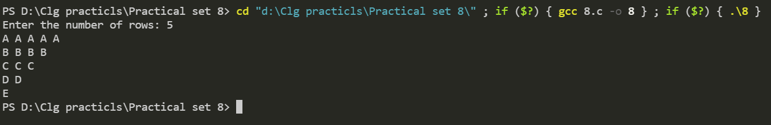

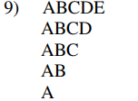

**CODE 9** :

#include <stdio.h>

int main()

{

int n;

printf("Enter the number of rows: ");

scanf("%d", &n);

char c = 'A';

for (int i = n; i >= 1; i--)

{

c = 'A';

for (int j = i; j >= 1; j--)

{

printf("%c ", c);

c++;

}

printf("\n");

}

return 0;

}

**OUTPUT 9 :**

